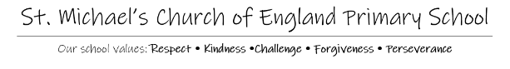
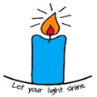
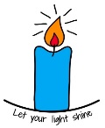

Dear Parent/Carer,
This school year we have been implementing the PSHE (Personal, Social and Health Education) Programme across our school called Jigsaw, the mindful approach to PSHE. The lessons, have built children’s emotional literacy, self-esteem and knowledge of who they are and how they relate to each other and the world in a positive and healthy way.
In this half term, the children will be following the Puzzle piece ‘Changing Me’. Each year group will be taught appropriate to their age and developmental stage. The following topics will be covered.
EYFS | Growing up: how we have changed since we were babies
Year 1 | Boys’ and girls’ bodies; naming body parts
Year 2 | Boys’ and girls’ bodies; body parts and respecting privacy (which parts of the body are private and why this is)
Year 3 | How babies grow and how boys’ and girls’ bodies change as they grow older. Introduction to puberty.
Year 4 | Internal and external reproductive body parts, body changes in boys and girls including menstruation
Year 5 | Puberty for boys and girls, and conception
Year 6 | Puberty for boys and girls and understanding conception to birth of a baby

We believe that knowledge empowers and protects children as long as it is age-appropriate. At secondary school, Sex Education is statutory and we believe that primary schools should prepare children with accurate knowledge about puberty and human reproduction before they transfer to secondary school. Correct terminology for body parts is introduced early to normalise this biological vocabulary and to support safeguarding. These words are not used in isolation but always in conjunction, ensuring children know these are private parts of their bodies.
Puberty is introduced gently in Y3 because some girls may start their periods this early and it is necessary to prepare them for this, so they aren’t scared or worried. Conception is introduced age-appropriately in Y4 in the context of understanding why our bodies change during puberty. Understanding of Human Reproduction, conception and puberty is built upon in Year 5 and then puberty, conception and childbirth is age-appropriately covered in Y6
We hope you will agree with us that this work is vitally important for children, that it needs to be done age-appropriately and that the Jigsaw Programme gives us a secure framework in which to do this. However, we do, as always, want to work in partnership with parents and carers, and also wish to inform you of your legal right to withdraw your children from some aspects of this work. Whilst most of this unit is statutory the right to withdraw applies to a couple of lessons in Years 4,5 and 6 that cover ‘Human Reproduction’.
There are more details on this on the PSHE section of our school website. If you would like to discuss this further, please don’t hesitate to contact school.
Many thanks

Mrs L Smith

